1.Write a JavaScript program to find the largest/maximum number from a given array of numbers.
arr = [5,2,9,33,55,11,6,88];
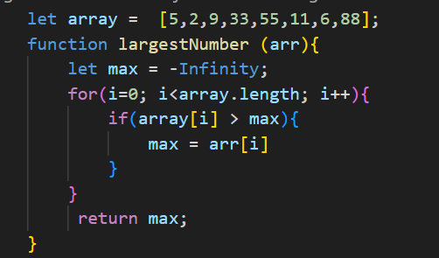
2.Write a JavaScript program to find the second largest/second maximum number from a given array of numbers.
